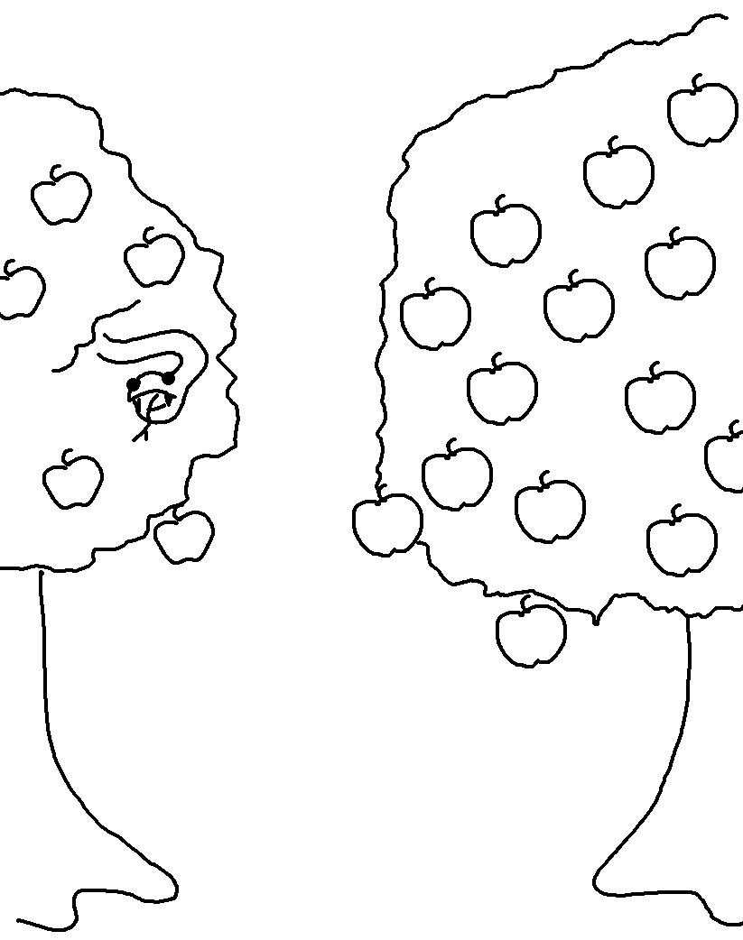
The free gift of God is eternal life through Christ Jesus our Lord. Romans 6:23_{NLT}

